*Big Data Developer*

*Assignment 1 –Import Acadgild VM into Oracle virtual box by following the document shared in the dashboard.*

Steps to import acadgild vm:

1. Open the virtual box and shown in scree short.

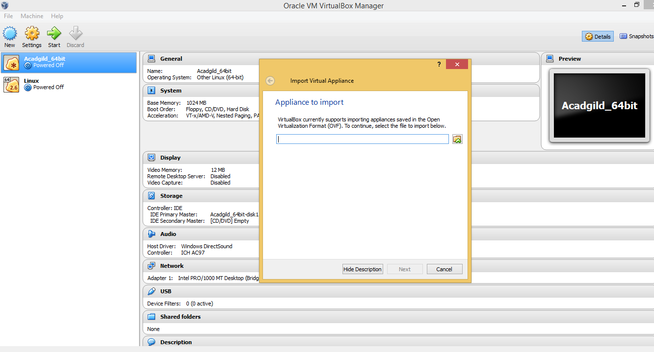

1. Click on the Folder option as shown in the below screenshot to browse to the location where hadoop vm is present. 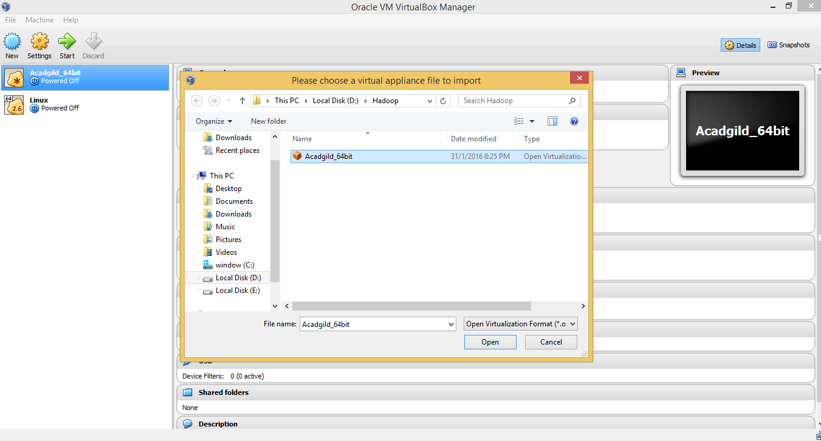
2. Once you open the file then click on import button to start importing the acadgild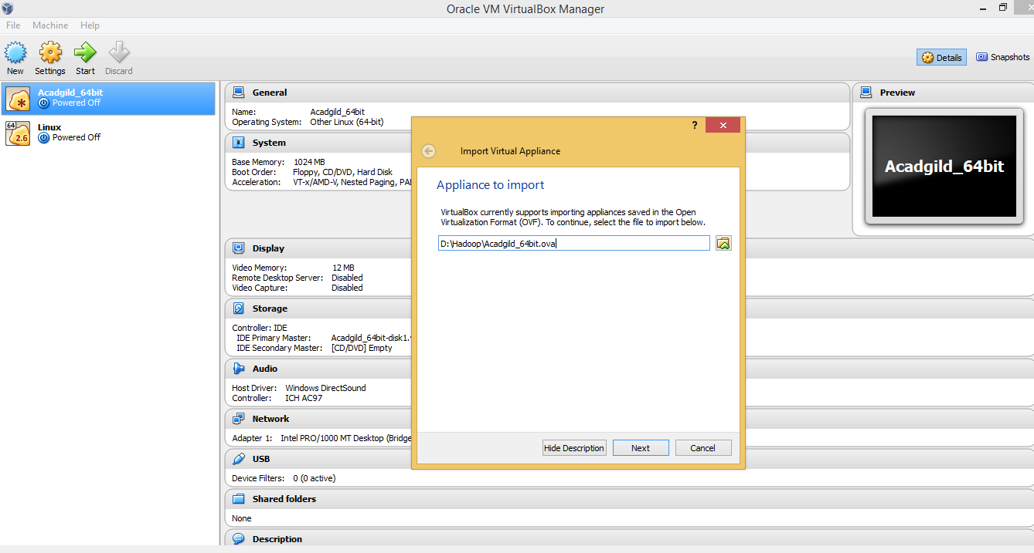
3. Setting are as below .

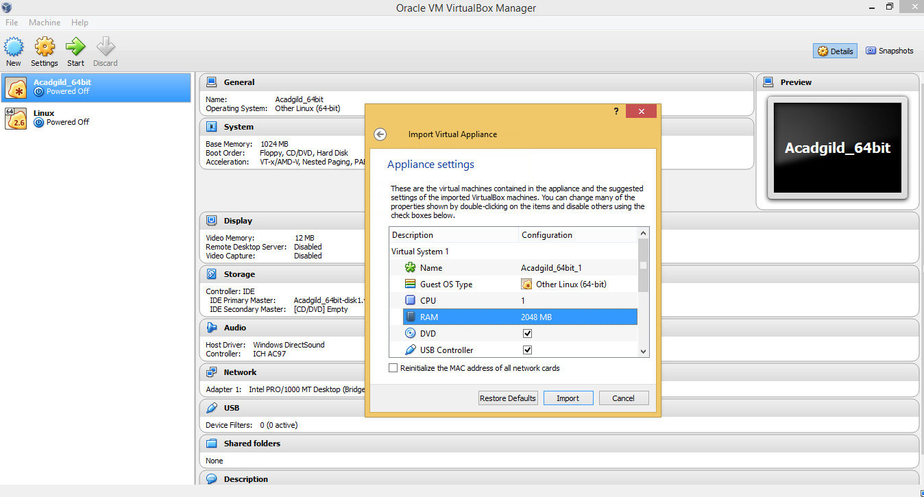

1. After Import completed 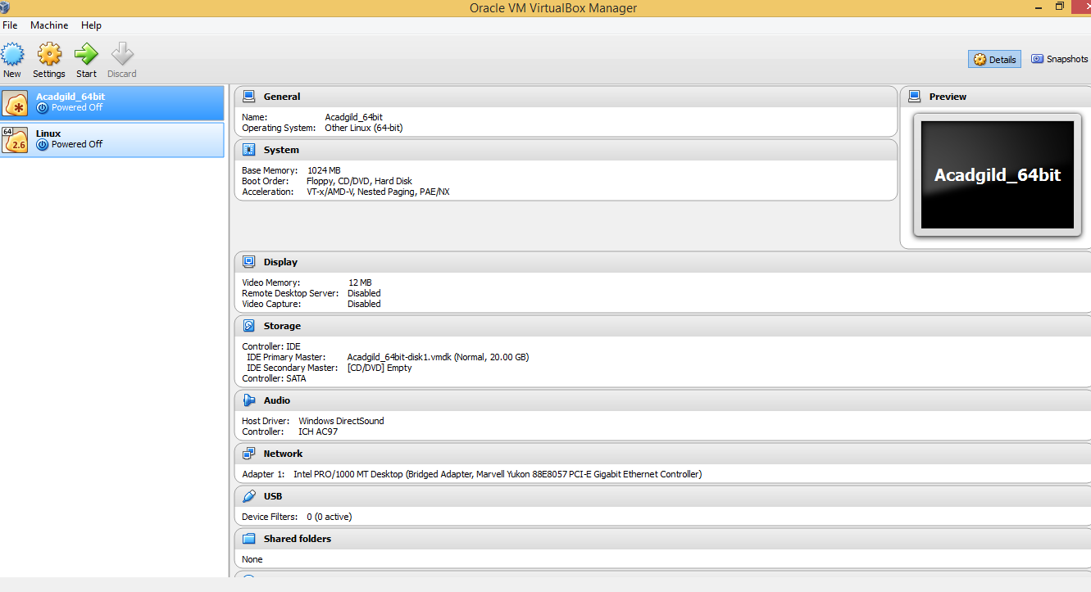
2. Login with default authentication .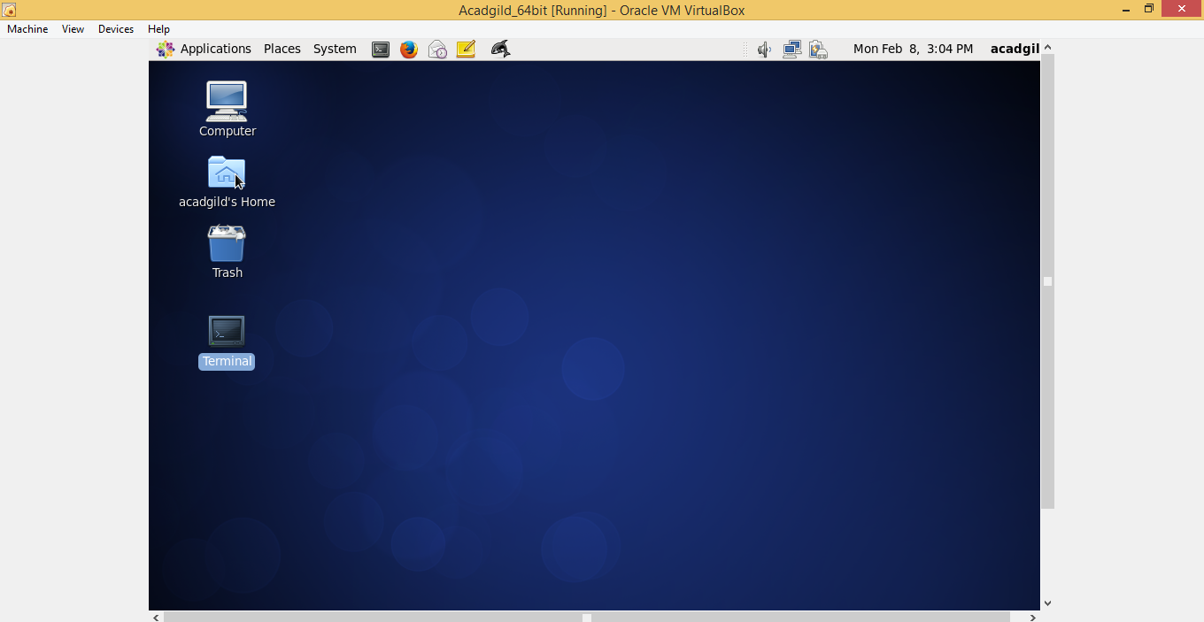
3. Open the terminal and type the command jps to check the list of daemons, we need to start all the daemons for the first time. 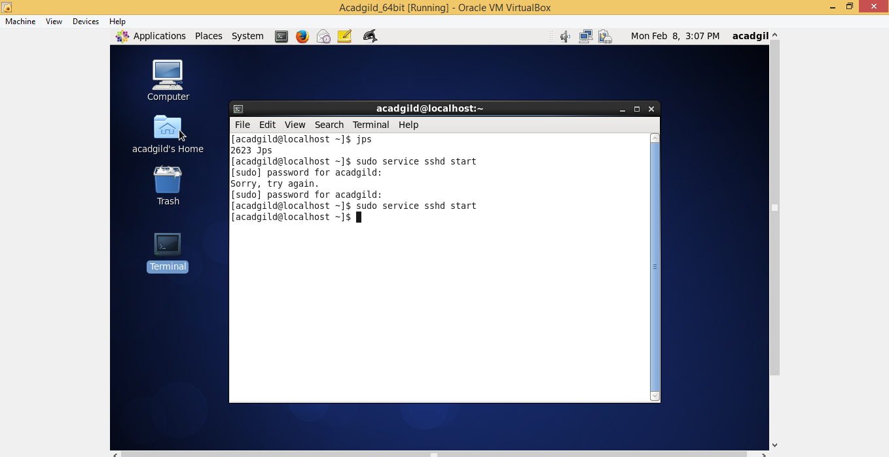
4. Open the terminal and start the ssh server. 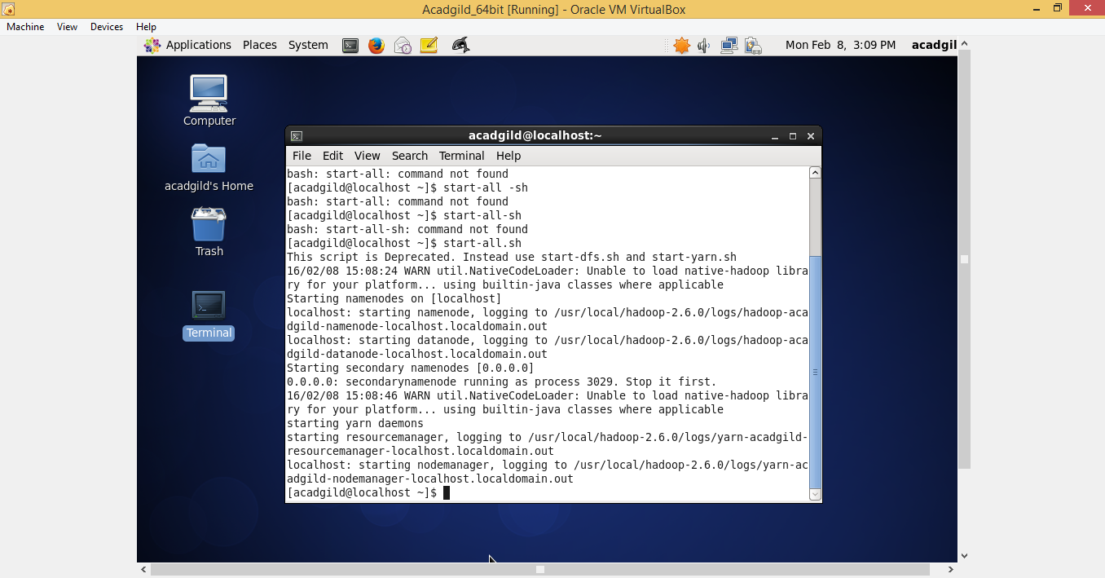
5. Start all the daemons and historyserver: 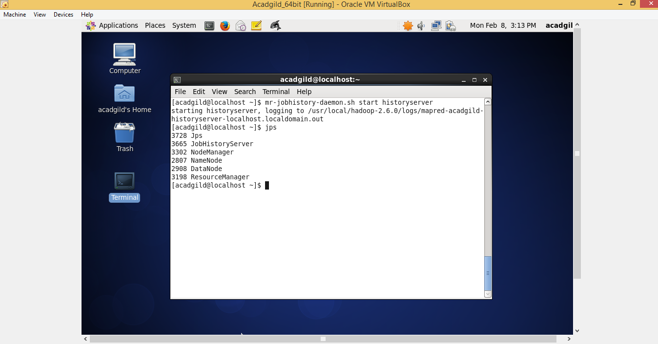
6. To start pig in hdfs mode ,type the command pig in terminal. 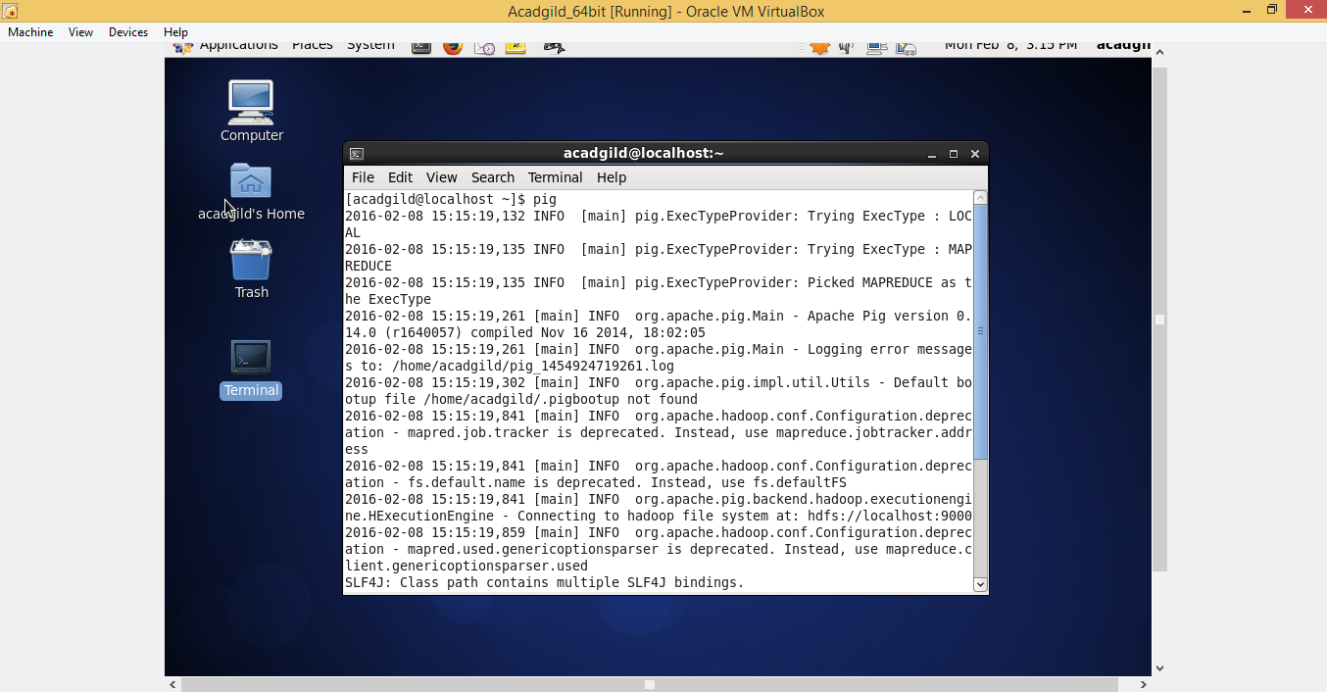
7. To start hive first start mysql service and then type the command hive. 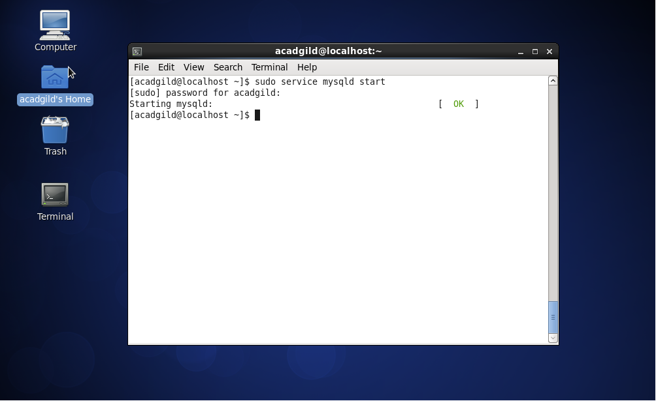 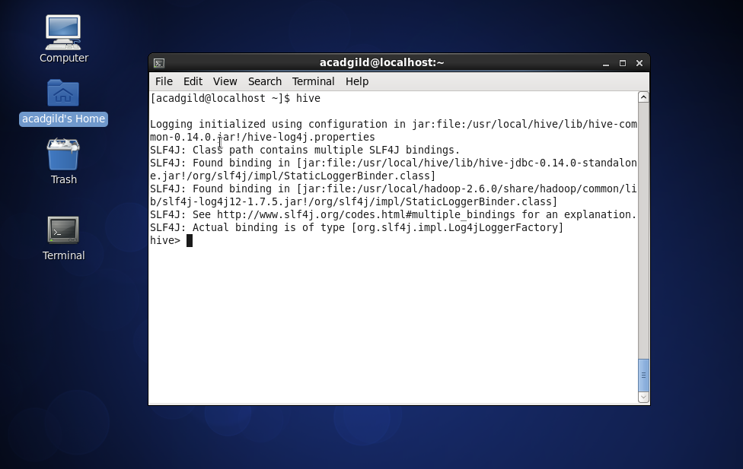
8. To start hbase type the below command as shown in the below screenshot. 